**Related Apps Review**

**Glympse – Share GPS Location**

**Google Play URL:** <https://play.google.com/store/apps/details?id=com.glympse.android.glympse>

**Screenshots:**

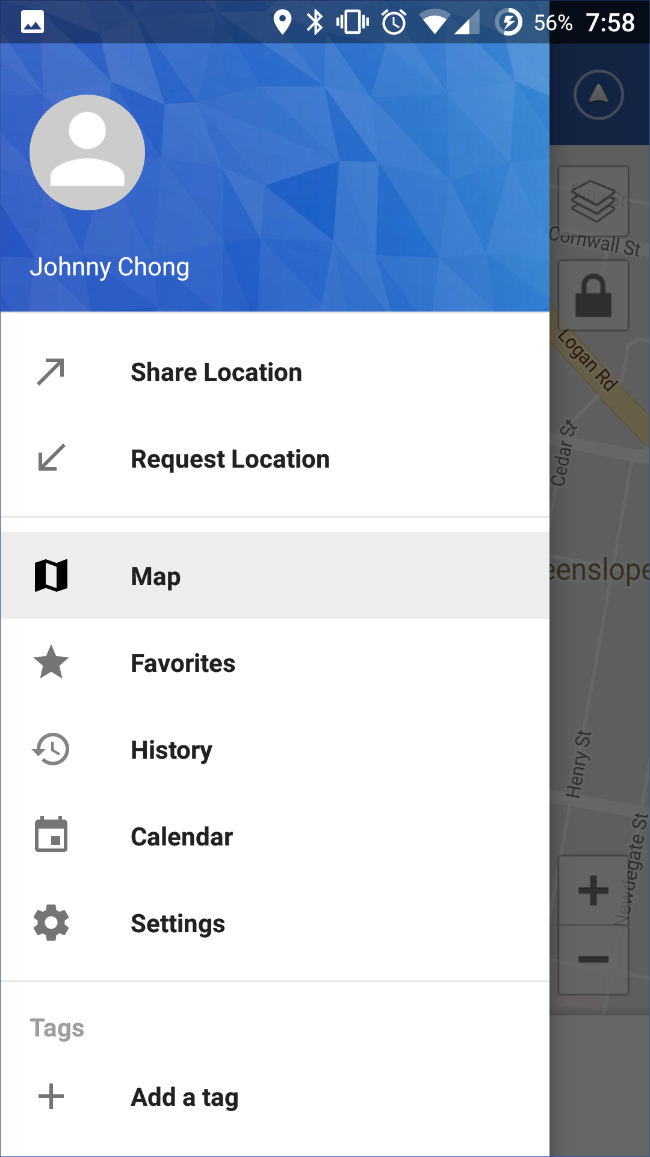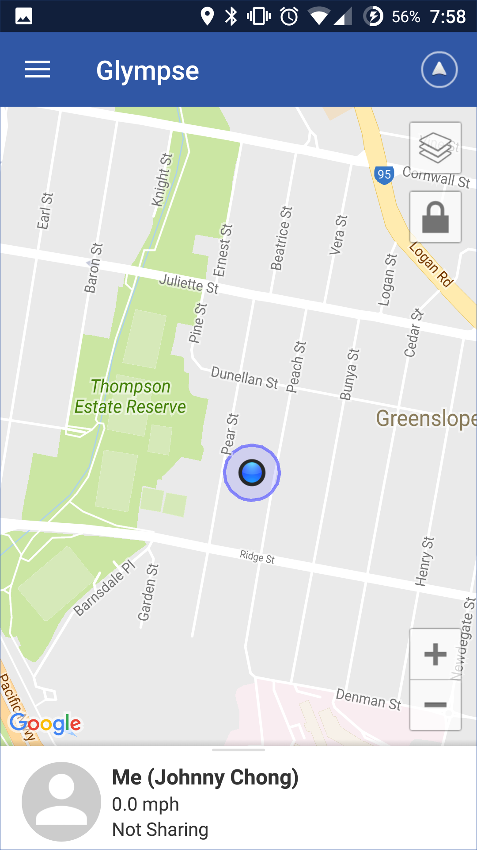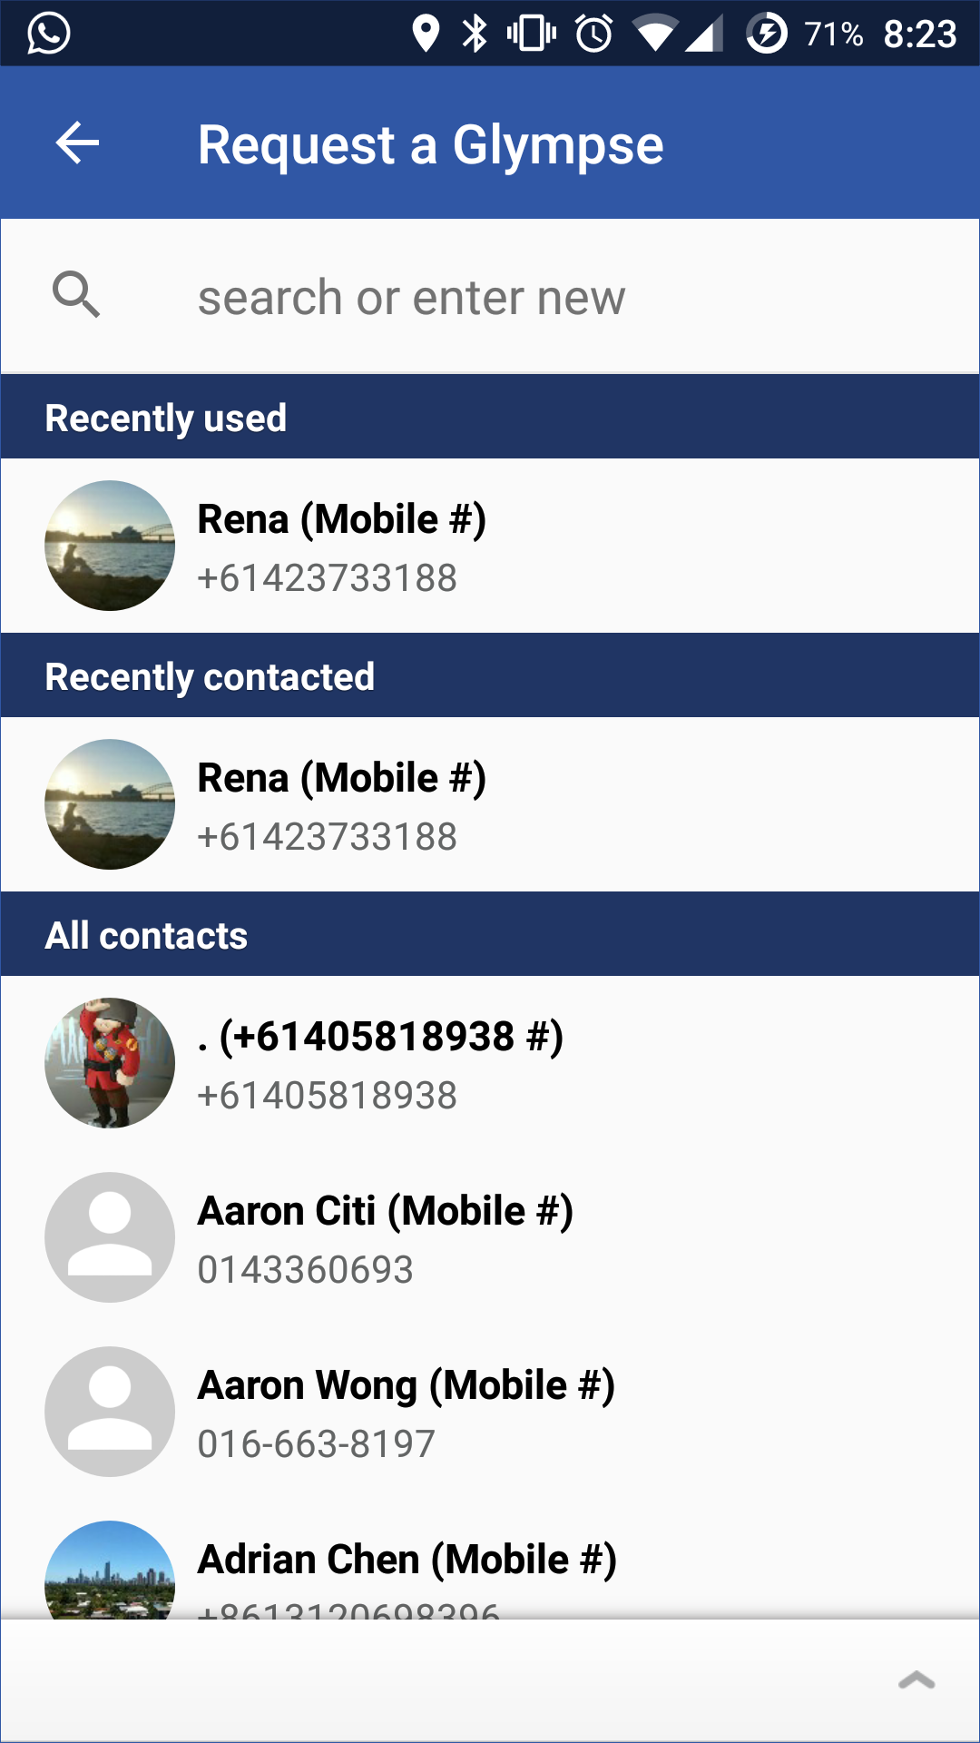

Splash Screen

Request Location

Menu

Home page

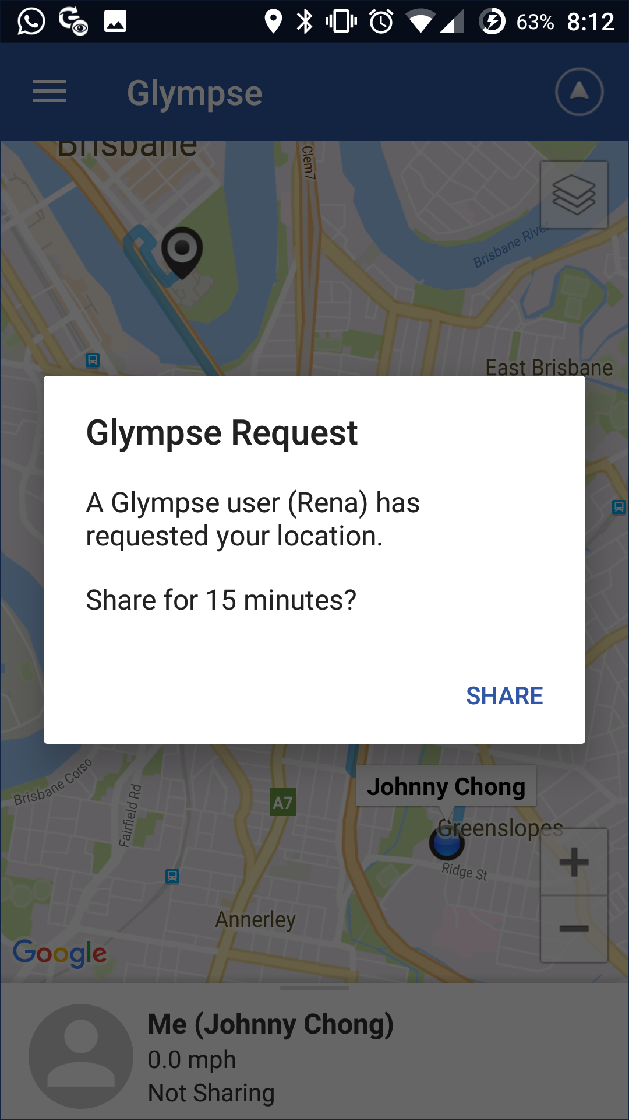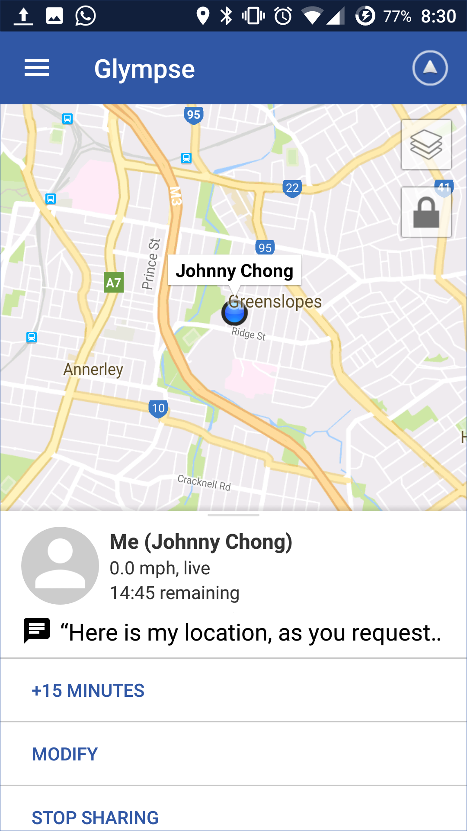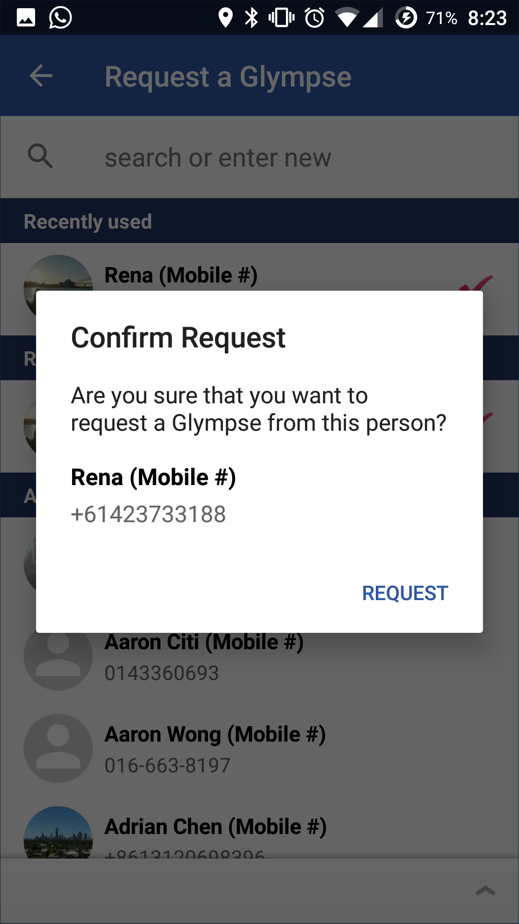

Sharing

Glympse Request

Confirm Request

**Description:** Glympse is a free and simple way to request or share location safely using GPS tracking in real time.

**How to use**:

1. Opening the app shows the splash screen briefly before the home screen is loaded.
2. To access the menu, slide right from the left edge of the screen or press the menu icon on the top left of the screen.
3. The two main features of this app are to share or request location. Choosing the request location option brings us to a contact list which is scrollable. New contact can be added by entering their mobile phone number in the search field.
4. A confirmation of request dialog appears after choosing a contact. A short message with a question and contact details are displayed in the dialog. Confirm the request by pressing the request button.
5. A notification will appear on the respondent’s screen. Opening the notification bring the respondent to the app with a dialog showing the glimpse request. Again, a short message is displayed in the dialog and tapping the share button confirms the request. A map with real-time GPS location is displayed on the screen with other information such as time remaining, message to requester, and stop sharing.

**Design & Interactivity**

**Positive**: The splash screen page is eye capturing with a simple logo and blue background. Overall colour and theme is simple and consistent throughout all the screens.

**Negative**: The app is supposed to a convenient tool to share users’ locations. The share location feature requires many steps to complete. There are too many options such as who, message, duration, and destination which lengthens the process of completing the task. As a result, users give up using the app and look for alternatives.

**Features & Functionality**

**Positive:** The map display and options are similar to google map which is familiar to most users. The calendar feature automatically syncs with the smartphone’s calendar events. Users are able to share their events from this feature which links to a location to share with other users. For instance, locations and estimated time of arrival can be seen by other attendees of a meeting or event.

**Negative**: The tag feature is confusing to users. Users are able to create a new tag which links to other users who uses the same tag. It was after many attempt until I learn how to use this feature. In my opinion, The feature can be scrapped as it clutters the app and confuses users.



Life360 – Family Locator

**Google Play URL**: <https://play.google.com/store/apps/details?id=com.life360.android.safetymapd>

**Screenshots**:

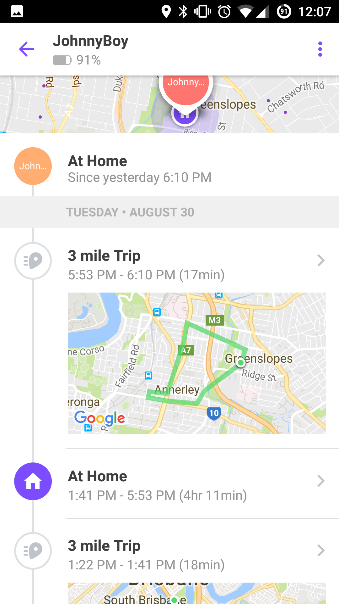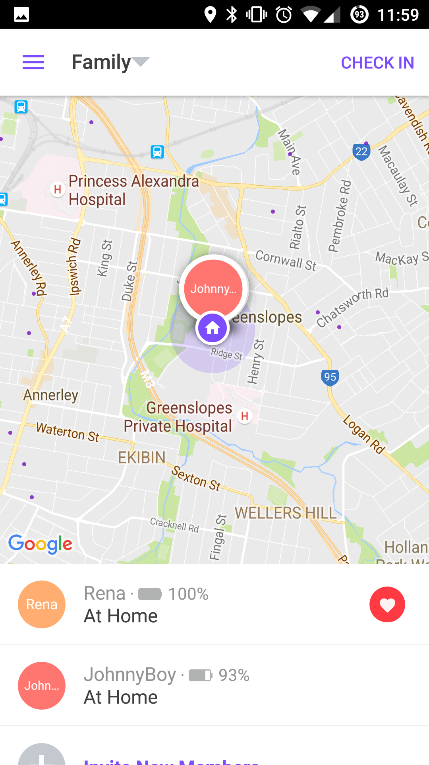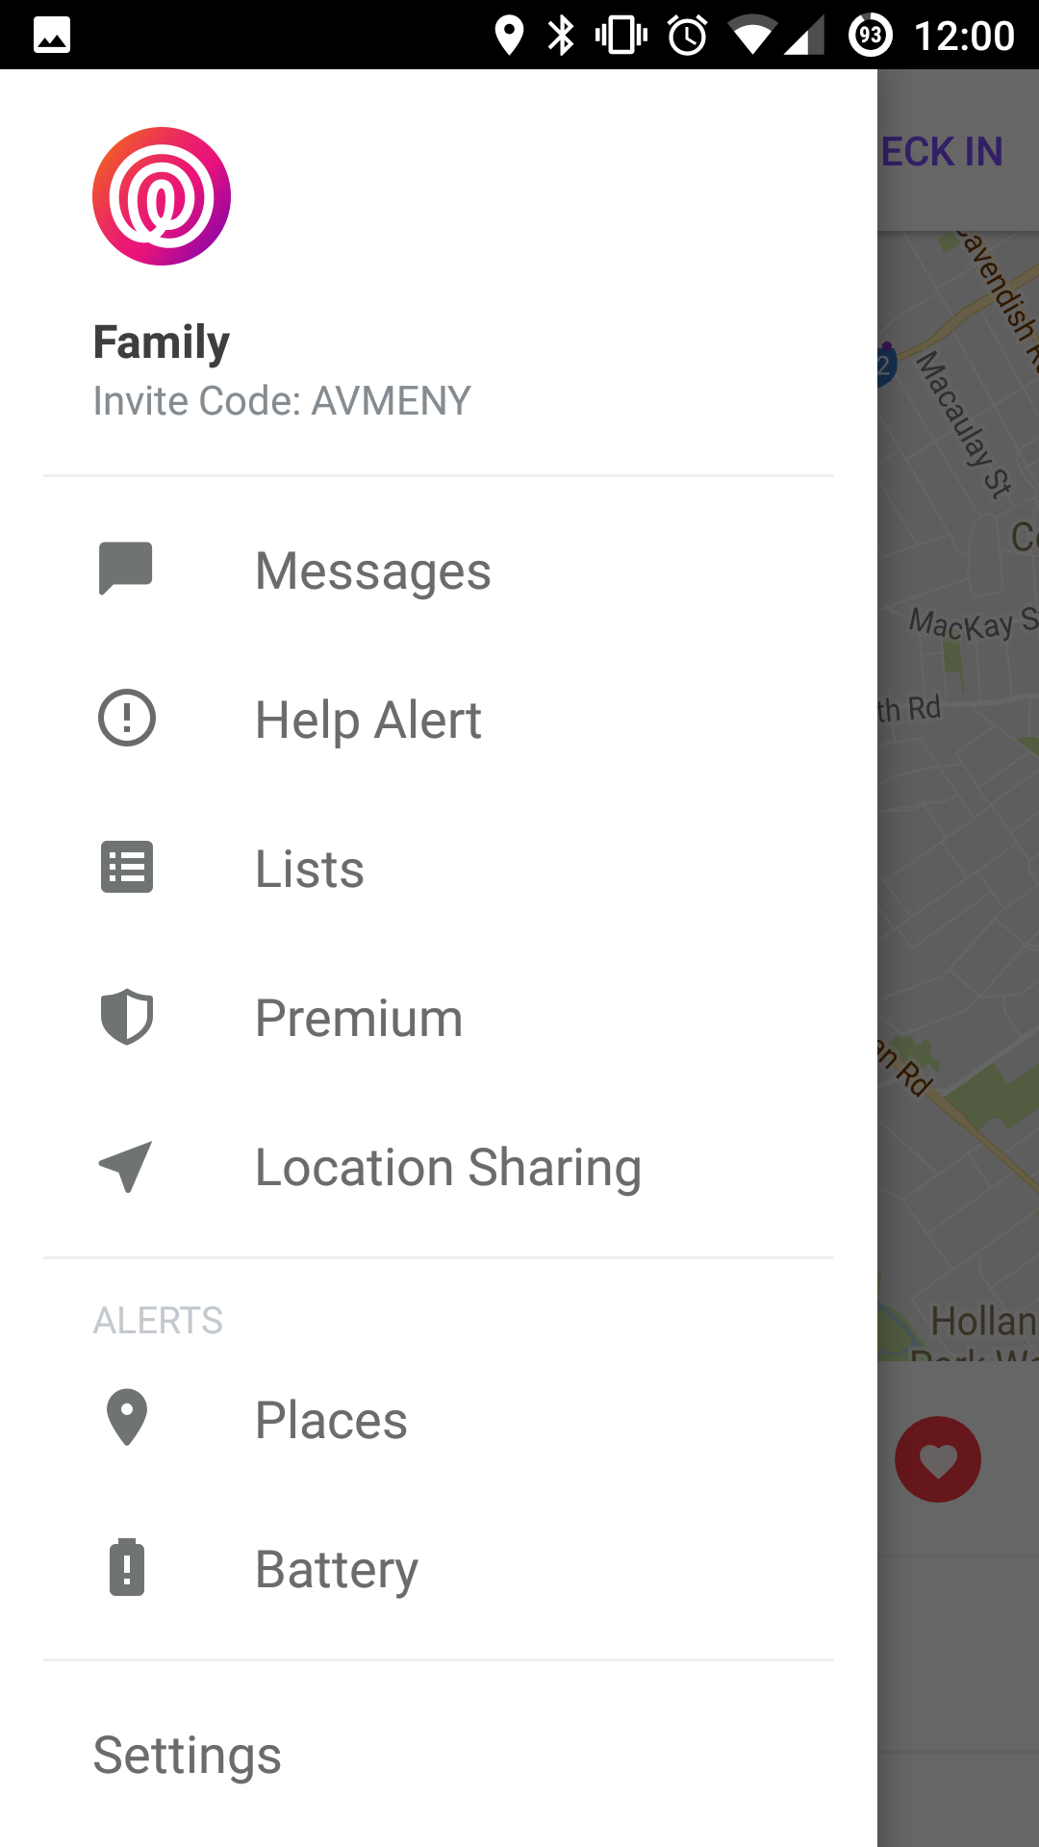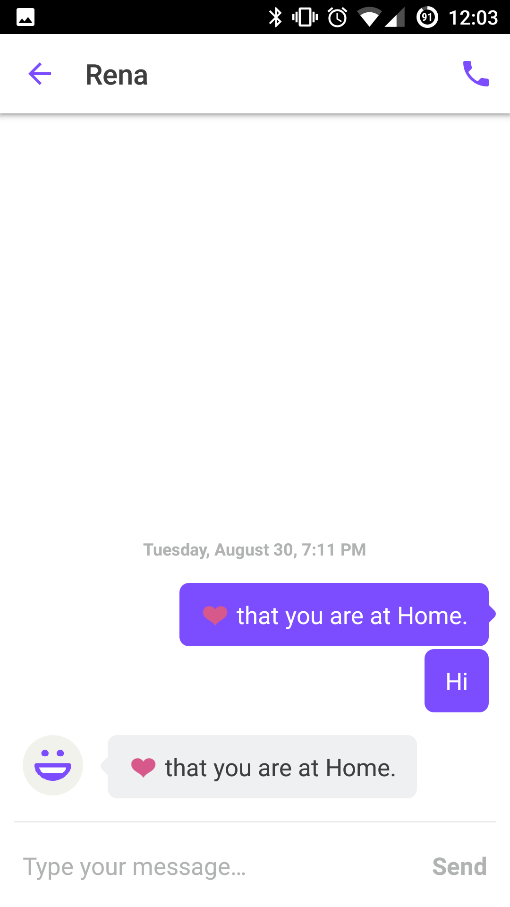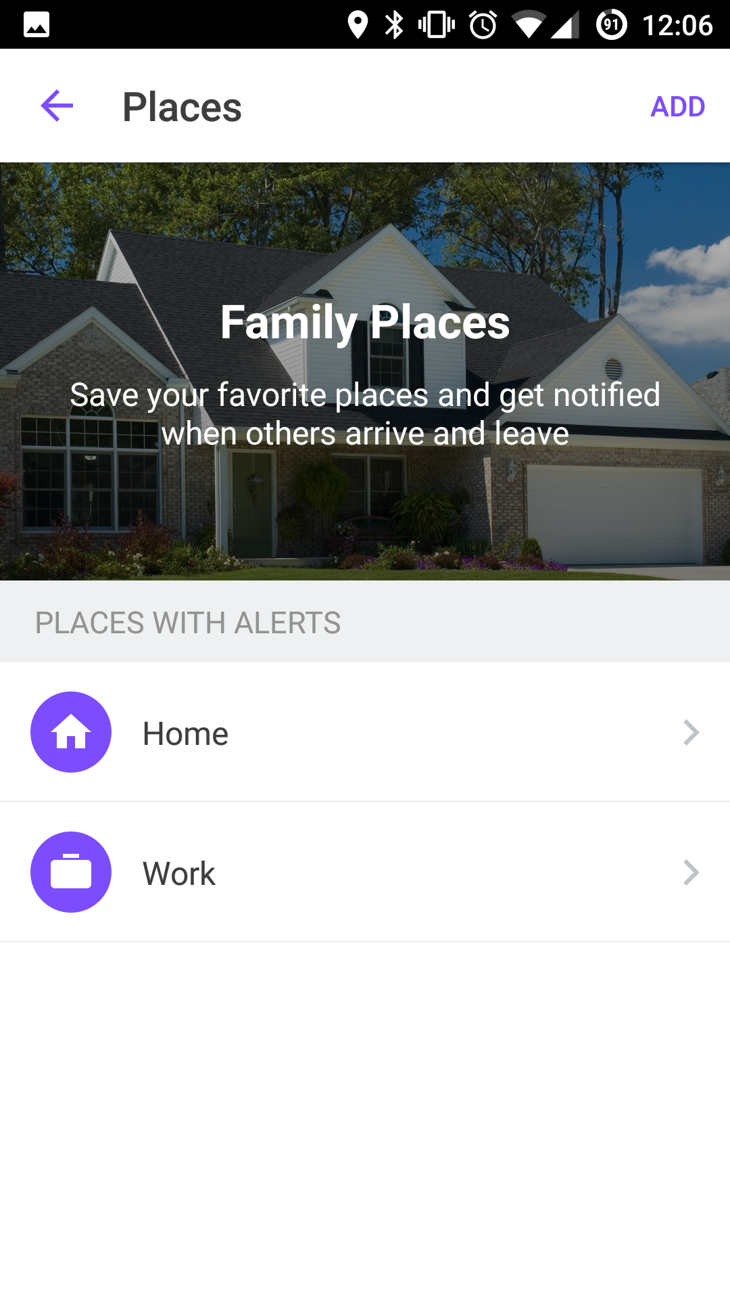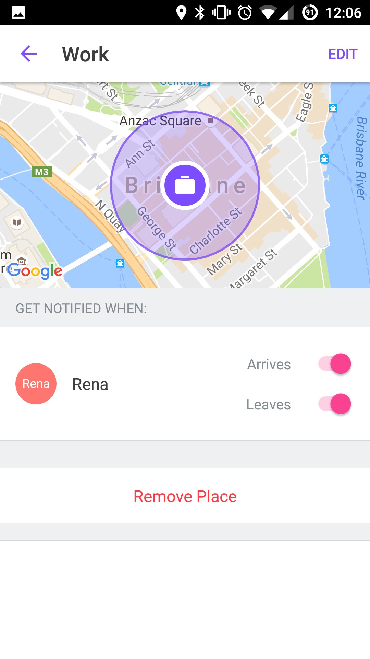

Messages

Home

Timeline

Menu

Places

Work

**Description**: Life360 is an app that uses GPS to track real time location. Aside from family, other circles such as friends or colleagues can be created. Members added to a circle appear on the map shown on the home page. Members of a group can chat with one another within the app. Users receive real time alerts when circle members arrive or leave a saved location.

**How to use**:

1. Opening the app shows a brief splash screen with a simple Life360 logo.
2. Tapping any names that appear on the home screen brings up a timeline of locations with detailed movement on a map.
3. New members can be added to a circle by selecting the “Invite New Members” option below the list of members on home page.
4. A user can check in to a place by selecting a location generated by Google nearby places (App uses Google Map API). Members in the circle will be notified of the check in no matter where they are.
5. To access the menu, slide right from the left edge of the screen or press the menu icon on the top left of the screen.
6. In the message feature, users can choose to chat from recent chat list or create new message to other users. Once a chat is opened, users can exchange text messages or call by pressing the call button at the top right of the screen. The call button opens the phone dialler and initiates the call automatically.
7. Users can save favourite places and get notified when others arrive and leave.

**Design & Interactivity**

**Positive**: The overall user experience and user interface is well designed. The app is inspired by Google’s material design concept which can be seen by the material icons used and the google card-like interface. The app is simple and easy to use but yet detailed enough to have very useful information such as the battery life of users. Complex abstraction can be seen in the timeline where important information is presented with minimal graphic and texts.

**Negative**: I am very satisfied with the design and interactivity of this app. Using the app gives me the impression that the creators have put in much thoughts in the interaction design of the app.

**Features & Functionality**

**Positive:** The developers make clever use of Google Map API by enhancing existing features such as getting notified if others arrive or leave a place. The chat feature eliminates the use of other messaging apps, thus prolonging the use of the app. Another two features worth noticing are the Help Alert and Lists feature. Help Alert notifies everyone in a group and up to three other contacts by tapping a button in the case of emergency and help. Lists feature adds extra value to the app by allowing users to create and share lists such as grocery lists and to-do lists to people in a group.

**Negative**: The only complaint that I have is the power consumption of the app. The app runs in the background and uses GPS to provide real time location. Before using the app, I get around 30% battery remaining after a full day of use, after using the app, I get around 10% remaining at the end of the day. In addition, notifications of the location updates are frequent and sometimes annoying.



Skype

**Google Play URL**: <https://play.google.com/store/apps/details?id=com.skype.raider>

**Screenshots:**

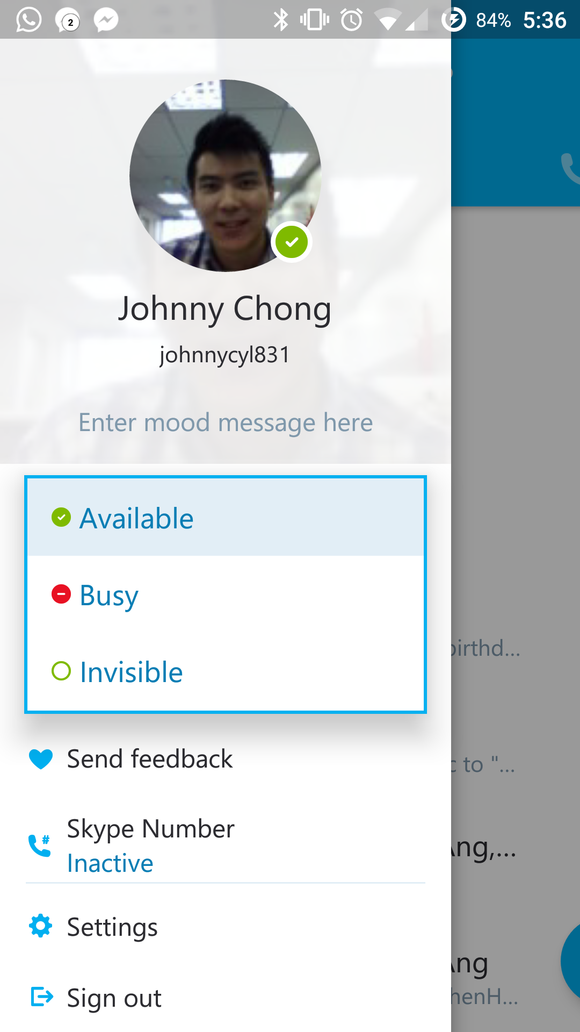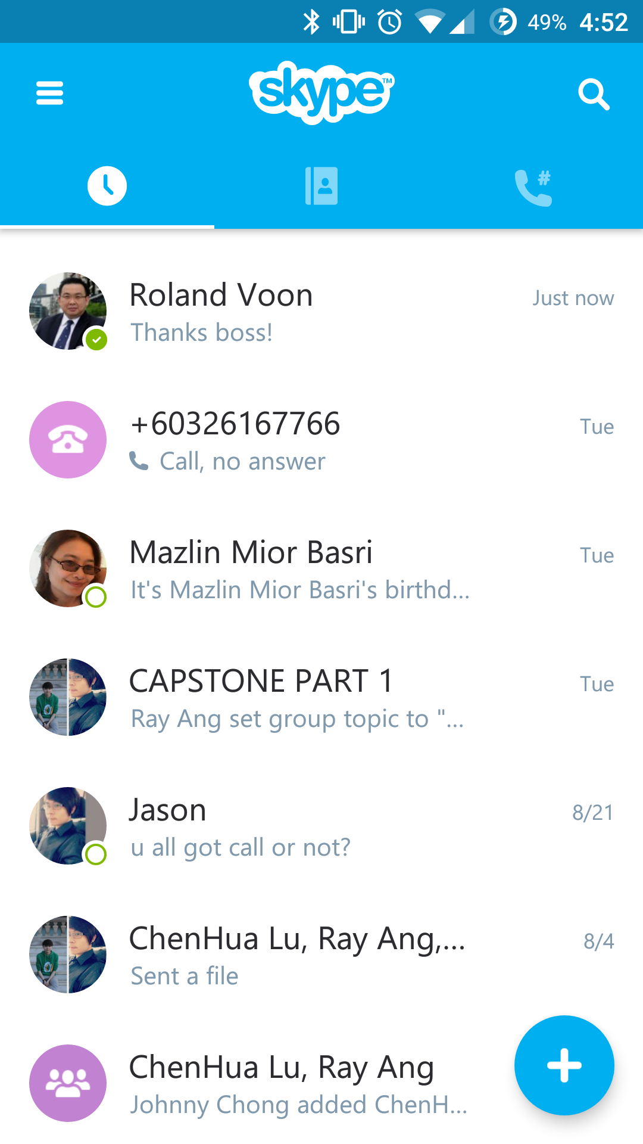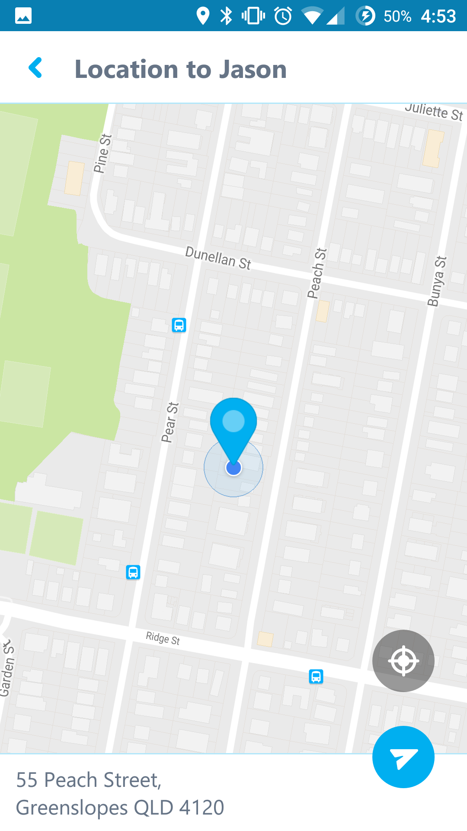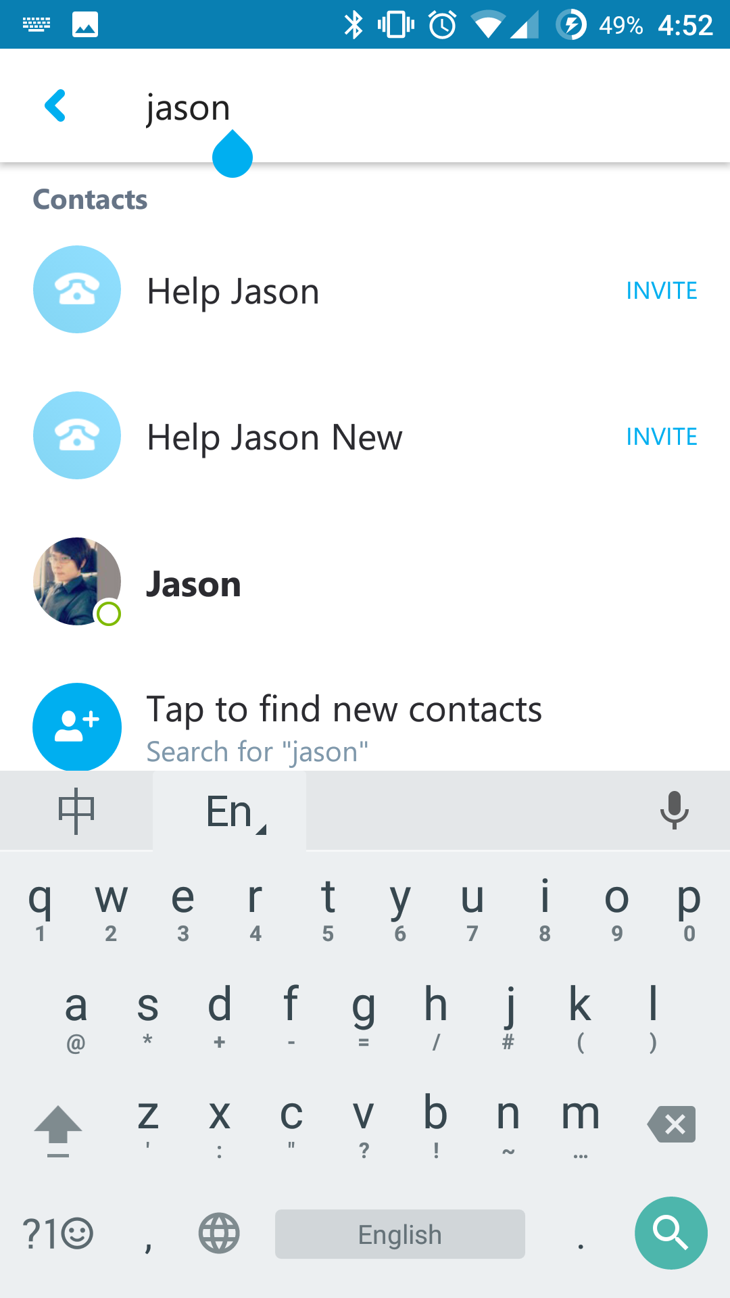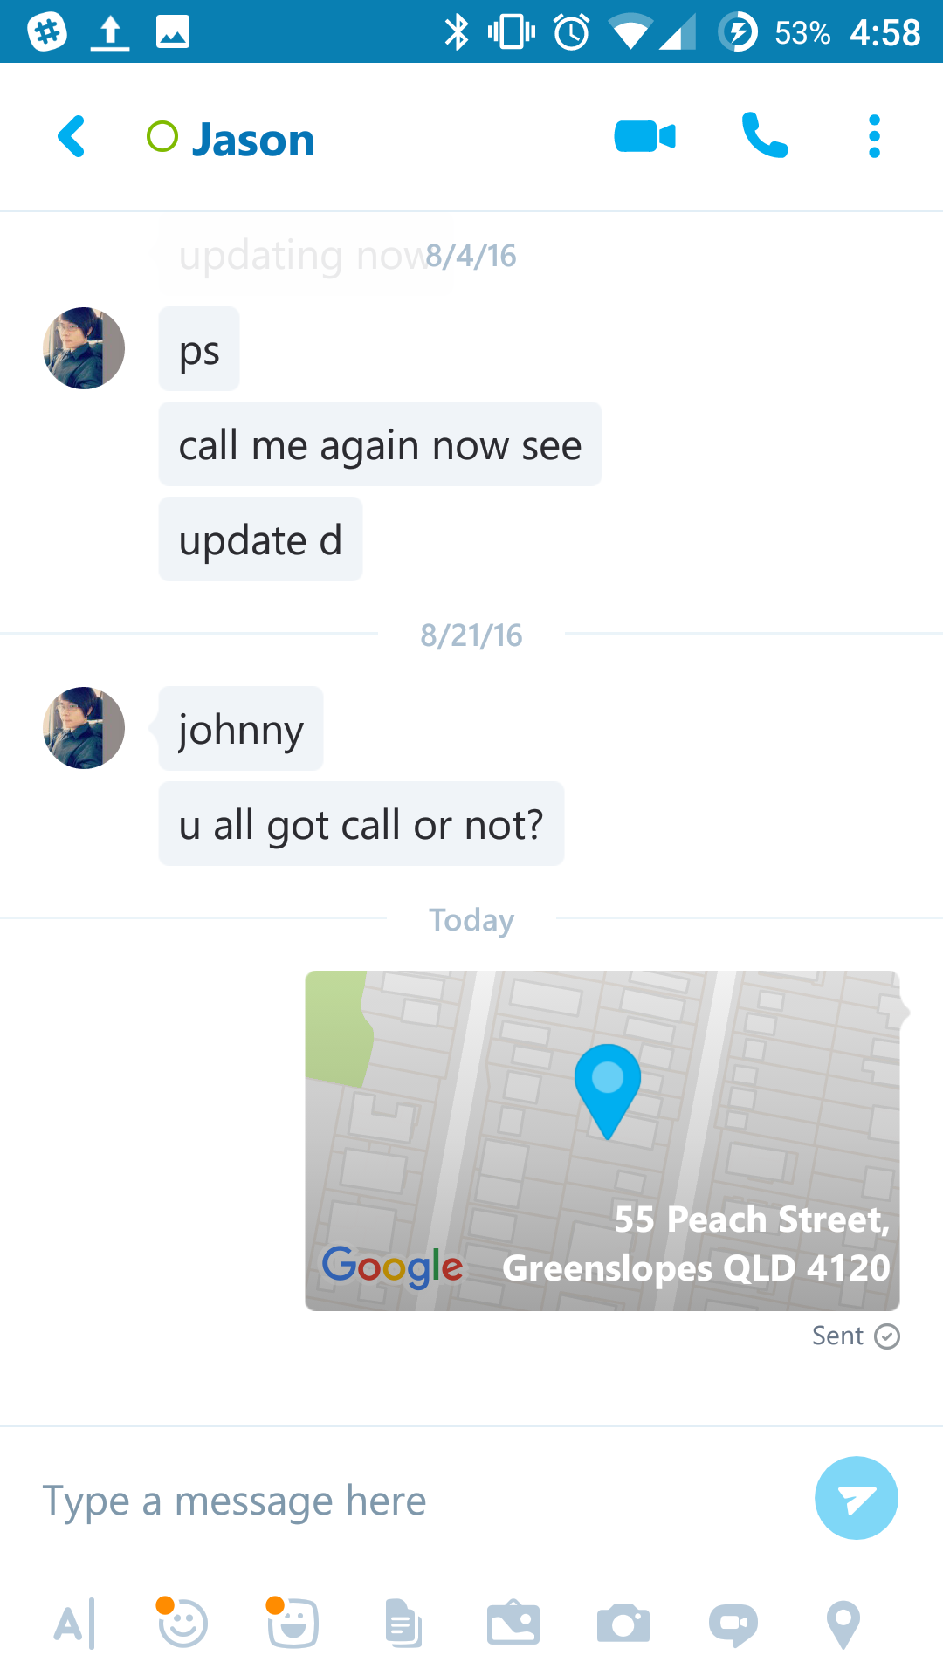

Chat

Share Location

Menu

Search

Home Screen

**Description**: Skype is a free instant messaging, voice or video call solution for all devices, regardless of operating systems. Like any other chatting software, Skype features sharing of photos, files, emoticons and even location.

**How to Use**:

1. Opening the app show a blank splash screen until the home page loads.
2. The design and interaction of the recent chats, contacts and recent calls is similar to what our team have in mind. Users can navigate to different screens by swiping left or right, or tapping one of the tabs above. The tab indicator indicates which screen is displayed.
3. The search button at the top right of the screen brings up a search page where a user can search for other contacts.
4. To access the menu, slide right from the left edge of the screen or press the menu icon on the top left of the screen. The menu is generally for settings and preferences. The main features are all accessible from the home screen or within a chat window.
5. Status can be changed by selecting one of the three options: available, busy or invisible. The available and busy status are made public to others while invisible makes a user appear offline, great feature if you do not want to be disturb by anyone.
6. In addition, a mood message tells everyone about your current mood and situation.
7. Within the chat window, users are able to share their location by selecting the location icon at the bottom right of the screen. A map appears and location can be set by dragging and dropping the pin to a desired location. The location shared is displayed on the chat window.

**Design & Interactivity**

**Positive**: The colours and theme are consistent throughout all the screens. The use of Android TabWidget to organize the recent chats, contacts and recent calls greatly reduces clutter in the screen, making it simple to navigate and use. The responsiveness of the app is excellent which can be seen in the transition of screens, button presses or actions.

**Negative**: The skype logo located at the top of the screen does nothing. Tapping the logo produces some animation but other than that, it has no functionality. The contact list does not have a scroll bar to scroll through long list of contacts.

**Features & Functionality**

**Positive:** The share location feature is useful and easy to use. It uses the google map API which is familiar to most users. Simplicity is present in the drag and drop interface while choosing a desired location to share. Sharing of status and mood message are visible to everyone which eliminates the need to send request.

**Negative**: I have no complaints about the features and functionality of Skype. The features are useful and functional. The only downside is that there is no unique selling point to differentiate itself from other competitors.